**The Road to School: How Far Students Travel to School in**

**Denver, Detroit, New Orleans, New York City, And Washington D.C.**

**Executive Summary**

*To Come*

**The Impact of Student Travel on Academic Outcomes**

Issues of travel time and quality can have variable impacts on a student’s academic outcomes. A long commute to school could affect student’s ability to get to school on time, her number of absences, and her availability to participate in before- or after-school activities (Blackmon and Cain 2015; Canfield et al. 2016; Grossman, Walker, and Raley 2001; Teasley 2004). However, a long commute to school could also serve as an indicator a student’s willingness to travel to an option that she or her family perceive as the best option.

The use of school-provided transportation (typically yellow bus service) is often the easiest option for families, but may bring logistical challenges for schools. For example, school-provided transportation can limit available school starting times. School start times have been shown to have an impact on student achievement, and older students, who are often assigned the earliest start times, tend to benefit the most from a later start (Carrell, Maghakian, and West 2011; Wolfson et al. 2007). Changing district bus schedules to give older students a later start time is one relatively low-cost solution, but many district (Wahistrom 2002). But other types of transportation changes, particularly in bus schedules, may be accompanied by an increase in costs (Edwards 2012; Jacob and Rockoff 2011).

In surveys, parents indicate that they factor student transportation into their decisions on where to send their children to school. A survey of parents in eight cities found that the percentage of parents who reported finding transportation to and from school as a problem ranged from 19 to 32 percent, depending on the city. In many of the surveyed cities, parents with less formal education (high school diploma or less) were more likely to report difficulty with transportation than parents with more formal education (bachelor’s degree or higher) (Jochim et al. 2014). A study of school lottery choices in Washington, DC, estimated that a typical middle school parent would be willing to travel an additional 1.2 miles for a 10-point increase in the rate of “proficient” test scores (Glazerman and Dotter 2016).

Issues of race, ethnicity, and class also interact with trade-offs between school quality and transportation. An analysis of students entering high school in Chicago showed that students from affluent neighborhoods were more likely to attend school close to home, but students from low-income neighborhoods were more likely to travel farther and were 35 percent more likely to be the only student from their neighborhood at a given school (Burdick-Will 2015). In Denver, black families were more likely to apply to a distant, high-quality school than Hispanic or white families (Denice and Gross 2016).

**The Landscape of Education in Cities with School Choice**

All five cities in our study have dramatically increased the choices available to students who live in the school district. Students in these cities have the opportunity to enroll in non-neighborhood schools (traditional, magnet, and charter), and may also have access to outside options through private school scholarship programs and inter-district choice. Each city has evolved a different set of choices for their students over time, but the nearby public school options available to different students often varies more across cities than across demographics within a given city.

***Increased School Options and School Choice***

All five of our study cities have substantially increased the school options available to local students, through policies such as inter- and intra-district choice, growth of charter schools, and tax credit scholarships or vouchers for private schools (Figure X). Many of these policies, such as inter-district choice or school voucher policies, are implemented at the state level. In some cases, school choice policies are implemented at the state level but mediated through local districts. For example, inter-district choice programs typically rely on the capacity of neighboring receiving districts.

Most of our cities have adopted inter-district choice, where city students may attend schools in nearby school districts, as policy since the mid-1990s or earlier. Inter-district choice may only be an option if the receiving district agrees and has space. In Washington DC, inter-district choice to schools in Maryland and Virginia is an option, but only if the sending student’s family pays a tuition to the receiving school district. Intra-district choice, where students are able to attend schools outside their zoned neighborhood school, has been implemented in our study cities as early as 1994 (in Denver) and as late as 2009 (in Detroit).

All of the cities in our study have charter schools within their district boundaries. The earliest charter school law affecting cities in our study was passed in Colorado in 1993, while the latest was passed in in 2000 in Louisiana. Districts have different levels of control over the development of new charter schools within their boundaries. For example, in Denver, charter schools have a contract with Denver Public Schools, and the Denver Public School Board decides on the opening and closing of schools. In Detroit, the district may authorize charter schools, but schools may also be authorized by public higher education institutions and intermediate (county-level) school districts.

Two of our cities also have publicly-funded private school choice. Since 2004, low-income students living in Washington D.C. have been able to access private schools through vouchers provided by the federally-funded D.C. Opportunity Scholarship Program. Through state programs, low-income New Orleans students may have access to private schools through vouchers provided through the Louisiana Scholarship program (2008) and via donated scholarships through the Louisiana Tuition Donation Rebate Program (2012). In addition, all families in Louisiana are able to claim tax deductions for private school expenses under Elementary and Secondary School Tuition Deduction (2008).

**Figure X: School Choice Policy Timelines**

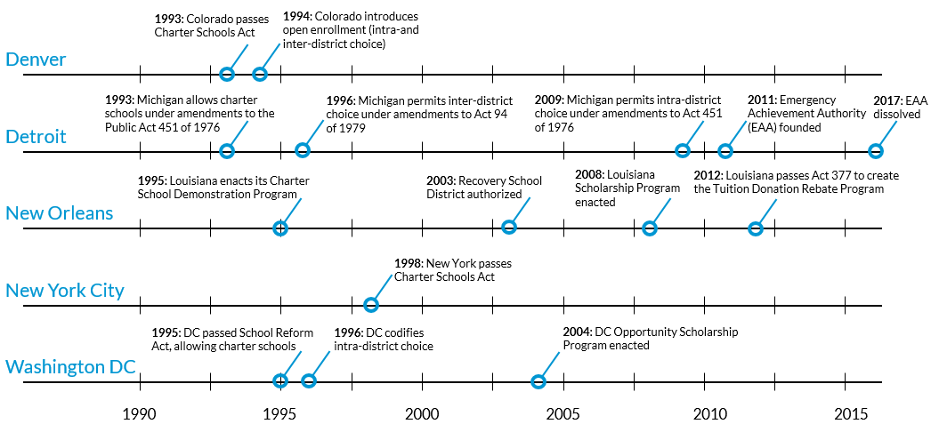

**Source**: Urban Institute analysis school choice legislation.

**Note**: In Washington DC, inter-district choice options predate the 1990 start date of this timeline, with inter-district choice programs dating back to the 1950s and 1960s. In addition, intradistrict choice has been an option in at least some New York City Community School Districts, such as East Harlem’s District 4, since the 1970s.

The increase in school choice policy in these cities has led to an increase in both new schools overall, as well as charter schools. However, the patterns of these increases over time have varied by city. For example, when we look at the opening of new schools (defined as a school that has a new National Center for Education Statistics identification number), we find public student enrollment trends that are influenced not only by changes in policy, but also by larger economic and demographic changes (figure X).

**Figure X: Enrollment in New Schools Over Time, Fall 1987 to Fall 2014**

|  |  |  |
| --- | --- | --- |
| **Denver** | **Detroit** | **New Orleans** |
|  |  |  |
| **New York City** | **Washington DC** |  |
|  |  |  |

**Source**: Urban Institute analysis of NCES Common Core of Data from Fall 1986, 1990, 1994, 1998, 2002, 2006, 2010, and 2014

**Note**: Analysis is of student membership in city public schools that were operational during the school year.

The largest enrollment change occurs in New Orleans, where enrollment dropped sharply after Hurricane Katrina, as measured in the fall of 2006, and has slowly recovered more than half of its previous enrollment. Most of the recovery has been in the form of enrollment in new public schools, many of which were founded after the storm. In Detroit, the decline in student population echoes declines in the city’s overall population. However, even as enrollment falls, Detroit has opened a substantial number of new schools; more than half of Detroit public school students are enrolled in schools that were founded after the fall of 1987.

Shifts in enrollment in new public schools are less dramatic in Denver, New York City, and Washington DC, but patterns still emerge. For example, schools that were founded in in the period from fall 1999 forward tend to enroll a larger share of students than schools founded before this period. Part of the reason for this trend is the increase in the number of new schools during this time. For example, roughly 230 new schools opened in New York City in the twelve years between fall 1987 and fall 1998, but about 710 new schools opened in the twelve years between fall of 1999 and fall 2010. Many of these schools may be small schools that are based in what was once a larger comprehensive high school, particularly in New York City, where the movement was prevalent (link). The evolution of new school options, whether in new buildings or co-located in previous school locations, can be considered a change in the set of school choices that students must make.

While all cities have seen large increases in enrollment in relatively new schools, enrollment in new charter schools is more variable across these cities. For example, New York City and Denver have seen relatively low charter growth, as a percentage of total enrollment, while a large majority of New Orleans students are now enrolled in charters (figure x). Detroit has seen substantial growth it enrollment in the charter sectors, with a large portion of enrollment emerging from schools that were founded before the fall of 2002. Likewise, Washington DC has experienced an increase in charter school enrollment, with the largest portion of charter students enrolled in schools that were founded between fall of 2007 and fall of 2010.

**Figure X: Enrollment in Charter Schools Over Time, Fall 1987 to Fall 2014**

|  |  |  |
| --- | --- | --- |
| **Denver** | **Detroit** | **New Orleans** |
|  |  |  |
| **New York City** | **Washington DC** |  |
|  |  |  |

**Source**: Urban Institute analysis of NCES Common Core of Data from Fall 1986, 1990, 1994, 1998, 2002, 2006, 2010, and 2014

**Note**: Analysis is of student membership in city public schools that were operational during the school year. In some cases, schools that did not report as charters in previous years of data later reported as charters under the same NCES school ID. Those schools are counted in the first year that they identify as a charter school.

***Cities Exhibit Differences in School and Student Location***

While new school choice policies – and the subsequent founding of new schools – may have an impact on where students may go, the choices that are near child populations may vary by city and by demographics. Using publicly-available American Community Survey data, we assess the location of students relative to public schools by school age group – elementary (age 5-9), middle (10-14) and high school (15-17). Although proximity to schools does vary by poverty status as well as race and ethnicity, we find that proximity to schools generally varies more across our five cities than within student demographics in the cities (appendix table X).

When we look at the percentage of school-age students who have at least one public (traditional or charter) in their home neighborhood (defined as the Census tract), we find substantial differences across city and grade (figure X). For example, while nearly 60 percent of elementary-age children in Denver have at least one public elementary school in their neighborhood, just 21 percent of elementary-age students in New Orleans have a school in their neighborhood. The likelihood of having a nearby public school generally declines as students grow older, though this decline also varies by city. For example, students in Denver and Washington DC generally see a much steeper decline in availability of elementary schools relative to middle schools in their neighborhood. In Detroit and New Orleans, students experience a steeper drop-off in neighborhood school availability between the middle school and high school years.

These trends could reflect historic school siting policies (e.g. an effort to have elementary schools that serves individual neighborhoods, or an effort to locate high schools in the urban center), but could also reflect the preferences of families. For example, families that prefer that their students walk or bike to school may opt to move to a neighborhood with a local elementary and middle school. Families may also choose to live closer to schools if the nearby available housing stock is more amenable for families (e.g. multiple bedrooms).

**Figure X: Estimates of School-Age Children with At Least One Public School in Their Neighborhood**

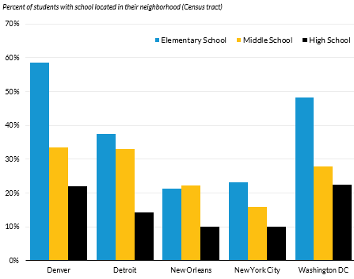

**Source**: Urban Institute analysis of NCES Common Core of Data from Fall 2014 and ACS tract-level data from 2010-2015.

**Note**: Analysis is of traditional and charter public schools that were operational during the school year. Schools that offer kindergarten are classified as elementary, 6th grade as middle, and 9th grade as high school.

The cities in our report differ not only in the availability of at least one neighborhood option for school-age children, but also in the total number of nearby school options. For example, the average New York City elementary school-age child has 11.5 schools within a one-mile radius, while the average New Orleans child has just 2.1 schools within a one mile radius. Of course, we would expect to see some differences in the cities based on differences in population density and urban form. However, across all cities, children from families in poverty to have, on average, an equal or higher number of nearby schools compared to children that do not come from families in poverty (table X).

There are many possible reasons for the trend of having more schools located close to students from low-income families. In cities with strong private school traditions (such as New Orleans), new public schools may be less likely to be sited near students who may have the means to attend a private option. Students from low-income households may be more likely to live in areas with a high population density, which might require higher number of schools to serve students in the areas. Further, school reforms aimed at improving the achievement of low-income students may have the effect of adding additional choices for students. For example, charter schools may locate in areas near low-income students, and new public options may be added through other reforms, such as the dividing of previously large traditional schools, or the founding of new traditional public schools.

**Figure X: Estimates of the Average Number of Schools Within a One Mile Radius for School-Age Children by Family Poverty Status**

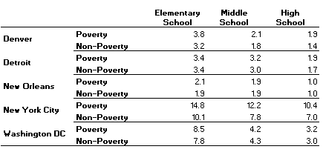

**Source**: Urban Institute analysis of NCES Common Core of Data from Fall 2014 and ACS tract-level data from 2010-2015.

**Note**: Analysis is of traditional and charter public schools that were operational during the school year. Schools that offer kindergarten are classified as elementary, 6th grade as middle, and 9th grade as high school.

When looking at the number of choices within one mile by race and ethnicity, the patterns within cities are less clear (appendix table X). For example, Hispanic and black students in Denver, New York City, and Washington DC, consistently have more nearby options than white students for elementary, middle, and high school. However, in Detroit and New Orleans, variations among the most common racial and ethnic groups are less pronounced, and, in some cases, white students appear to live closer to more schools than students of color.

**Methodology**

Our study focus on the development of transportation time estimates (both driving and public transportation) for students enrolled in public schools in our five cities. Using individual-level data on where students live and the schools they attend, we estimate travel times for kindergarteners in New Orleans, New York City, and Washington DC; for 6th graders in Denver, Detroit, and Washington DC; and for 9th graders in all five cities. We calculate the travel time for each student to her own school, as well as to all other schools that serve her grade. For consistency across cities, we report our results in terms of travel time by car or transit, rather than in distance traveled.

To calculate driving times and transit times, we use estimates obtained from the Google Distance Matrix API. To simplify calculations, students addresses were matched to Census blocks, and distance calculations were made from the population-weight centroid of each Census block.[1] Travel times were computed for a departure time that is a half-hour before the estimated start time for schools in the city, for usual traffic. In cases where a school is less than a half-mile as the crow flies from the student location, the walking time was also calculated, and the estimated walking time replaced the estimated transit time if lower.

Individual-level data for the study is from the 2013-14 school year, but Google API does not allow the calculation of travel times in the past. This study uses the estimate of driving and transit time as calculated for Wednesday, September 13, 2017. While our cities have made small changes to their transportation system in the intervening three years (for example, Denver opened two new commuter rail lines, and Washington DC implements quarterly adjustments to its Metrobus routes), we believe that these changes are not substantial enough to bias our estimates.

**Student Transportation in Five Cities**

***Transportation Policies Vary Across City***

Each of our cities have evolved their own set of transportation policies to move students to and from school. We provided detailed descriptions of the differences in these policies in our first report, *Student Transportation and Educational Access* (Urban Institute 2017). We focus on the transportation options that are available to students in our study, who were enrolled in kindergarten, 6th grade, or 9th grade. Table X outlines the transportations options for each grade of student in our study.

**Table X**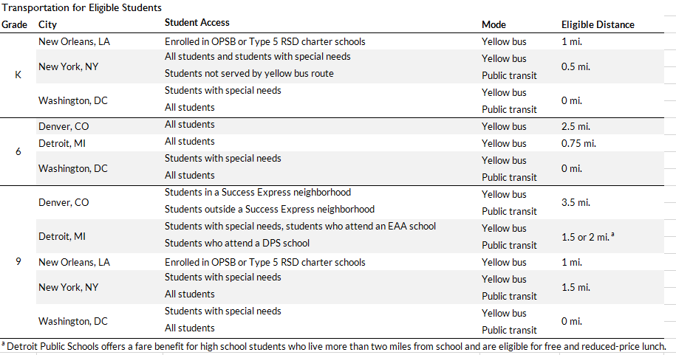

**Source**: Urban Institute analysis of district transportation policies.

**Notes:** New York offers half-fare public transportation to some students who live closer to school. See the appendix for full policy descriptions. For Denver, yellow bus includes both standard routes and Success Express routes. The Education Achievement Authority is Michigan’s state-run school district. A Type 5 charter school is a school chartered through the Recovery School District, Louisiana’s state-run school district. DPS = DetroitPublic Schools; EAA = Education Achievement Authority; OPSB = Orleans Parish School Board; RSD = Recovery School District.

In Washington D.C., all students enrolled in regular education are provided with a pass for use on public transit to get to school. High school students in New York City, as well as some high school students in Detroit and Denver, also are given public transit cards to attend school, depending on distance. Aside from in Washington DC, students in kindergarten and 6th grade in our other cities are typically given yellow bus service, provided they live a minimum distance from school.

While each city provides transportation options, the availability of these options may vary by the school the student attends. All of our cities offer transportation to the student’s neighborhood school, but transportation to non-neighborhood schools and charter schools varies. Washington DC and New Orleans provide yellow bus or public transit service to nearly all public schools, while Denver and Detroit are less likely to provide transportation to non-neighborhood or charter schools. Students in 6th grade or below in New York City typically receive yellow bus transportation to schools in their neighborhood school district or to charter schools within the same borough.

**Table X: Likelihood of Public Student Transportation Assistance by School Attended**

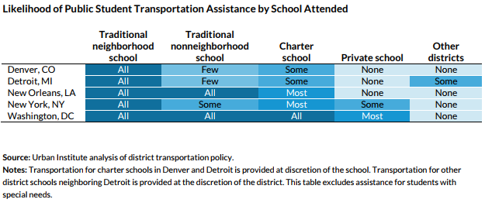

**Source**: Urban Institute analysis of district transportation policy

**Notes**: Transportation for charter schools in Denver and Detroit is provided at the discretion of the school. This table excludes assistance for students with special needs. See the appendix for full policy descriptions.

***School Districts Tailor Their Policies to City Transportation Resources***

Of our five study cities, New York City and Washington DC rely most heavily on public transportation to help students travel to school. Using our data on the driving and transportation time from each student block to each school they are eligible to attend, we can compare the relative efficiency of public transportation to driving in each city.

Figure X illustrates the results, plotting the mean public transit time for all trips that take a given number of minutes driving. The black line represents a scenario where public transit takes the same amount of time as driving (in usual traffic) would. As might be expected, traveling by public transportation take much longer than making the same trip by car. However, both New York City and Washington are closer to the parity between driving and public transportation. On average, a ten-minute car ride to a school is equivalent to a roughly 23-minute public transportation trip in these cities. In Detroit, Denver, and New Orleans, a ten-minute drive is more likely to take 32 to 34 minutes. As drive time increases, average transportation time grows at a slower rate in New York City and Washington DC, while transit time generally increases more linearly in other cities.

**Figure X: Comparison of Drive in Time in Traffic and Transportation Time**

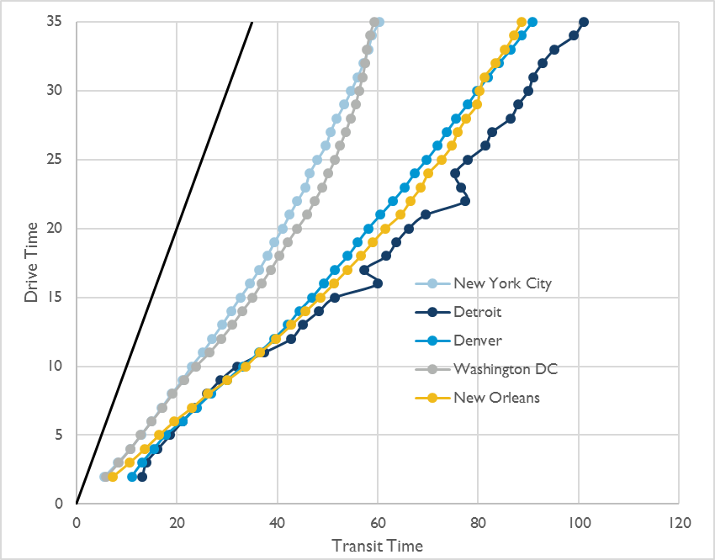

These result show that the policies enacted by our five cities are largely in line with the efficiency of the local transportation system. Cities that can more quickly deliver students to school tend to rely more on public transportation to transport students. In cities with less efficient transportation, students are more likely to be offered yellow bus service. However, high school students in Denver and Detroit may still be reliant on public transportation for school, which means that a school which is a 15-minute car ride away could easily be a 50-minute journey by public transit.

***Car Ownership is Lower in Neighborhoods with A Higher Percentage of Low-Income Families***

Access to a car is associated with an increased likelihood of employment among low-income households, as well as an increased likelihood of moving to neighborhoods with higher levels of school performance ([Pendall et al 2014](https://www.urban.org/sites/default/files/publication/22461/413078-Driving-to-Opportunity-Understanding-the-Links-among-Transportation-Access-Residential-Outcomes-and-Economic-Opportunity-for-Housing-Voucher-Recipients.PDF), [Gurley and Bruce 2005](http://www.sciencedirect.com/science/article/pii/S0094119005000434), [Ong 1996](https://academic.oup.com/swr/article-abstract/20/4/255/1615687)). When we look at car ownership in our five cities by Census tract, we find that the likelihood of owning a car decreases as the percentage of families in poverty increases (figure X). However, the overall levels of car ownership also differ across our five cities.

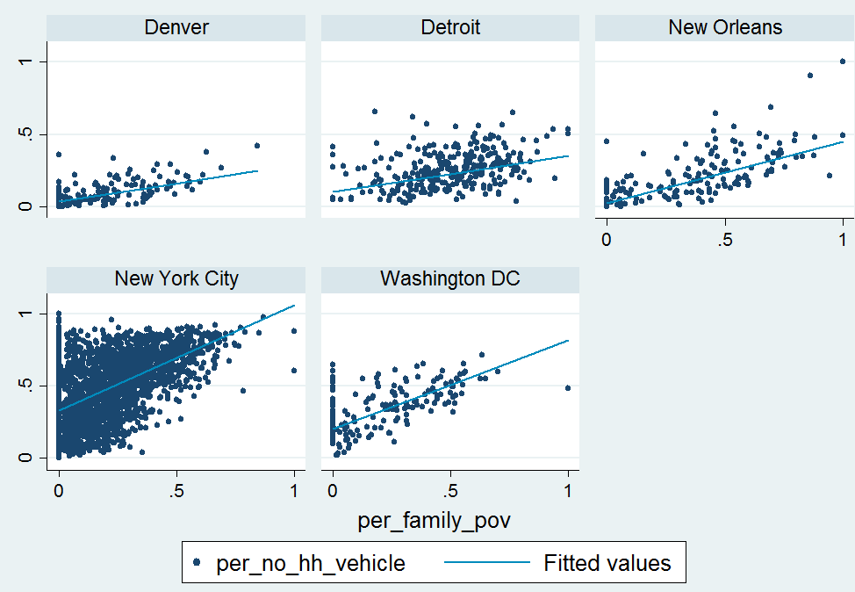Figure X: Car Ownership by Tract, Relative to Poverty of Families of School Age Children

Car ownership is more prevalent in cities with less efficient transportation systems. Even in Census tracts with the highest proportion of families in poverty, a household is more likely to have access to a car than not. In the highest-poverty quartile of Census tracts in Denver, just 15 percent of households have no access to a car (relative to 4 percent in the lowest-poverty quartile). In New Orleans, 30 percent of households in the highest-poverty quartile of tracts don’t have a car (relative to 6 percent). Within the highest-poverty Census tracts in Detroit, 28 percent of households don’t have a car (relative to 17 percent).

Cities with more robust transportation systems have relatively lower car ownership levels. 51 percent of households in the highest-poverty tracts don’t have a car in Washington DC (relative to 21 percent for low-poverty tracts), and 71 percent of high-poverty tracts in New York City don’t have a car (relative to 37 percent).

**Results for Five Cities**

At a high level, our results show that students in these high-choice cities are attending schools that are relatively far from home. However, different demographics of students appear to make different choices, traveling farther or “passing” relatively more schools to travel to their selected one.

***How Far Do Students Travel to School?***

Even when students have access to school choices across a city or within NYC borough, younger students tend to not to travel as far as older students (figure X). Among the three cities for which we measured travel by kindergartners, the estimated median travel time ranges from 3 to 9 minutes from home (driving with usual traffic). Among 6th graders, the median travel ranges from 6 to 9 minutes, and among 9th graders, the range increases to 10-15 minutes from home.

**Figure X: Quartile estimates of drive time to school (usual traffic)**

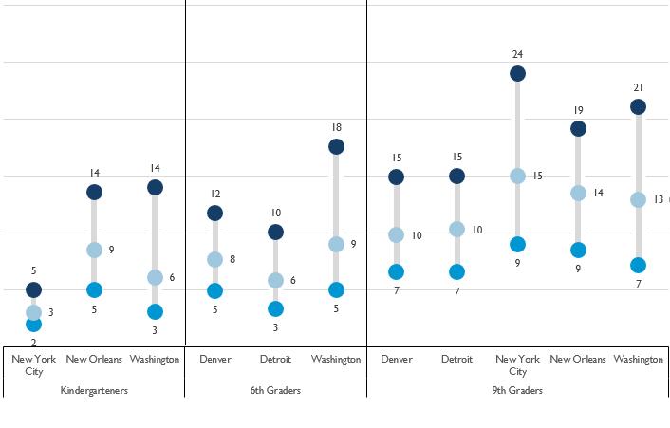

While few students live more than 25 minutes via car from their school, their commuting time increases at least twofold if they travel by public transportation. For kindergarteners, the median time by public transportation ranges from 7 minutes (New York City) to 27 minutes (New Orleans). Among 6th graders, the median time is 20 minutes for students in Detroit and Washington DC, and 26 minutes in Denver. For high schoolers, the median public transit travel time ranges from 27 minutes (Washington DC) to 45 minutes (New Orleans).

Within these estimates, we must also consider that students are subject to some level of travel time uncertainty, due to traffic or other factors. If a route is unreliable due to traffic, weather, or other factors, these estimates function as a minimum estimate. Because students travel to school with an implicit deadline (e.g. the first bell of homeroom), students and their families may also shift towards earlier departures to decrease the probability of arriving late ([Noland and Small 1995](http://www.its.uci.edu/its/publications/papers/ITS/UCI-ITS-WP-95-1.pdf)).

***Who Travels the Farthest?***

*By Race/Ethnicity*

In four of our five our cities, black high school students travel between 2 to 5 minutes more in driving time, on average, than their white peers (Figure X). Hispanic high school students do not travel as far as black students, and, in Denver and Washington DC, Hispanic students also have shorter driving time commutes than their white counterparts.

**Figure X: Average Driving Time, in Traffic, For High School Students, By Race/Ethnicity**

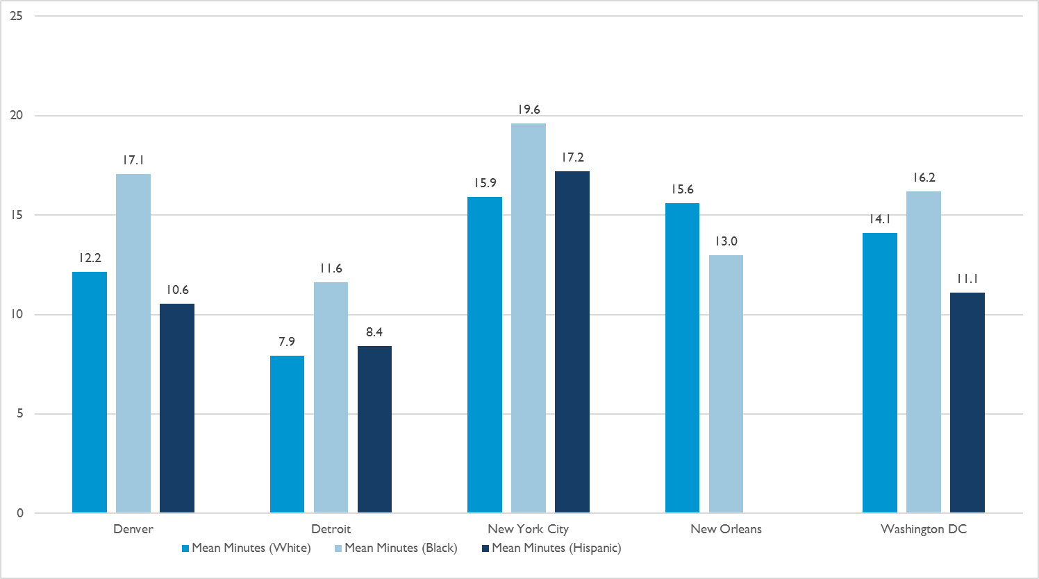

The pattern we observe in high school students carries through to students in the lower grades as well. In nearly every grade we observe, black students travel between 1 and 5 minutes farther, on average, than white students. This trend is not the product of a few outlier students – black students at the 25th, median, and 75th percentile all travel farther relative to their white counterparts.

*By Income*

When we look at travel time by family income, however, we observe that students who come from low-income backgrounds typically do not travel farther than their peers. In fact, in nearly every city-grade pair, low-income students face relatively lower travel times (figure X). The differences between the two groups are generally not as dramatic as the difference between black and white students, but they are relatively consistent across all five of our cities.

**Figure X:** **Average Driving Time, in Traffic, By Low-Income Status**

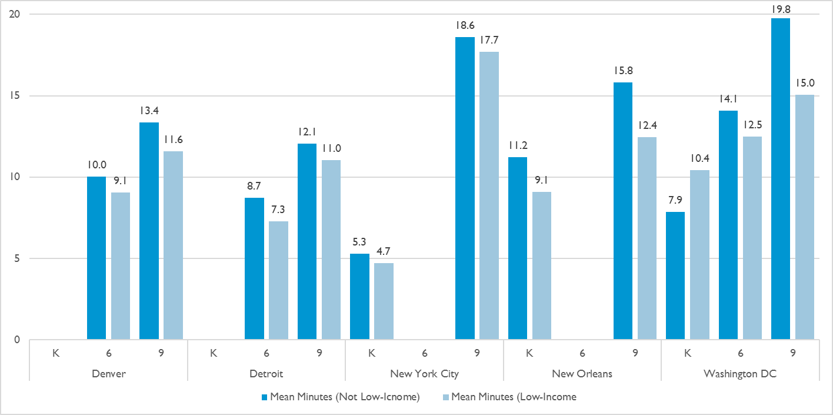

Because black students in these five cities also tend to be students identified as low-income, these results may seem surprising. However, these results emerge because of the high proportion of students (ranging from 75 percent in Denver to 92 percent in New Orleans) that are classified as low-income in our data. Among the few students that are not low-income, we often observe a reversed pattern by race: black students that are not low-income tend to attend distant schools, while white students that are not low-income tend to attend schools that are closer. An example from Washington DC illustrates this phenomenon, which also known as Simpson’s Paradox (figure X).

**Figure X: Travel Times among Black and White 6th Graders in Washington DC**



*By School Type*

Charter schools are often located in neighborhoods with a high number of students of color, and in neighborhoods where traditional public options may be perceived as underperforming by parents ([Jacobs 2011](http://journals.sagepub.com/doi/abs/10.1177/0013124511413388); [Burdick-Will, Keels, Schuble 2013](http://onlinelibrary.wiley.com/doi/10.1111/juaf.12004/full); [Glomm and Harris 2005](http://www.sciencedirect.com/science/article/pii/S0272775704001190)). Given this, we might expect that charter schools in our cities draw students from roughly the same distances as traditional public schools. However, demand for charter schools, as measured by student waitlists, is also high in our study cities, particularly in New York City and Washington DC. It is possible that charter schools in these cities may have more of a city-wide draw, and that students may travel farther to a school that is perceived to have a higher academic quality or a diverse student body ([Glazerman and Dotter 2017](http://journals.sagepub.com/doi/full/10.3102/0162373717702964)). It is also possible that capacity constraints at nearby charter schools could push students to more-distant charter options.

When we look at travel times by type of school attended, we see diverging patterns by grade level and city. Younger students attending charter schools (those in kindergarten and 6th grade) tend to travel as far, if not farther, than their peers who attend traditional public schools. However, among 9th graders, we see this trend reversed, and those attending traditional public schools tend to travel as far, or farther, than those in charter schools (figure X). Differences are most pronounced for younger students in New York City and Washington DC, while students in Denver tend to travel less far to charter schools than to traditional public schools. These grade level differences may emerge, in part, due to the function of high school within these cities. High schools are often seen as city-wide resources, offering specialized programs or vocational training that students are willing to travel farther to access.

**Figure X: Average Driving Time, in Traffic, By School Type**

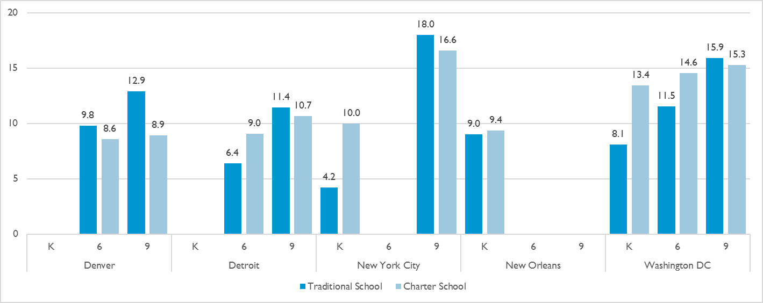

***Who Has Access to Choice?***

Most students in our study live less than fifteen minutes driving time to their school. Earlier, we showed that households in neighborhoods with a higher proportion of families in poverty were less likely to own cars. When we look at access to schools within a fifteen-minute radius, a fifteen-minute drive garners far more choice than a fifteen-minute transit ride. For nearly every grade, students have access to ten or more schools when traveling by car for fifteen minutes or less, but typically have access to fewer than ten schools when traveling for the same amount of time on public transit. Figure X illustrates this difference in access for 9th graders in our five cities (full table in appendix).

**Figure X: Average Number of Schools Within 15 Minutes, By Travel Mode**

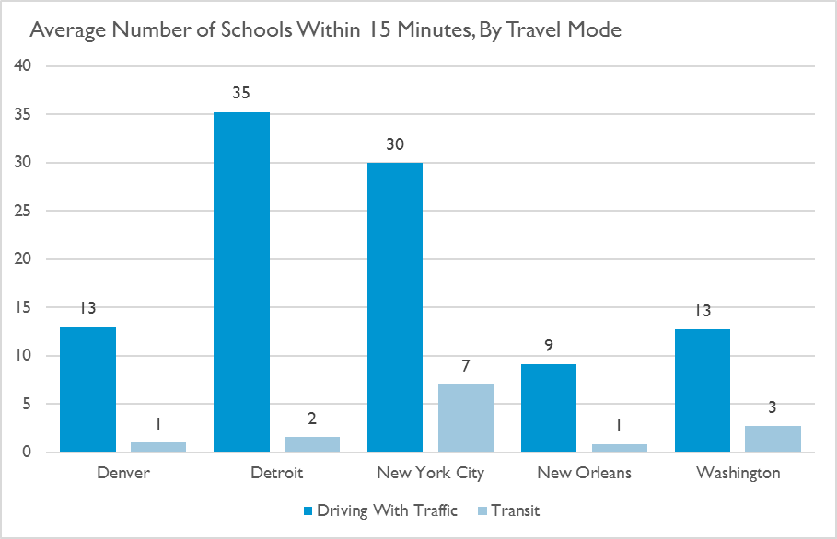

One measure of choice would be to look at whether students are selecting their nearest school, or whether they are traveling to more distant schools. In figure X, we look at the cumulative percentage of students who attend their nearest school, who “pass” one other option, two other options, and so on.

**Figure X: Cumulative Percentage of Students that Attend a Nearby School**

|  |  |  |
| --- | --- | --- |
| **Kindergarten** | **6th Grade** | **9th Grade** |
|  |  |  |
|  | | |

The results of this analysis show differences in school choice and attendance patterns by city and grade. 43 percent of kindergarteners in New York City attend their nearest school, while just 17 percent of those in New Orleans and 26 percent of those in Washington DC do. In high school, this pattern is reversed; just 35 percent of students in New York City attend one of their ten nearest school options. A much higher percentage of high school students in our other cities (from 48 percent in Detroit to 72 percent in Denver) attend one of their ten nearest schools.

While the range of school options within fifteen minutes of transit time may be relatively restricted in our cities, the majority of students in our cities attend a school that is not their closest school. In many cases, students travel farther than their ten nearest schools.

Given that household car ownership is correlated with family poverty in our cities, we also looked at the number of options that are close to students from low-income background. Similar to our estimates from Census data, we find that students from low-income families tend to have the same number, or slightly more, nearby options than students from non-poor backgrounds. However, we don’t see a distinct pattern in selection of proximal schools by income status across our city (see appendix).

*More Here….*

***How Connected Are Students to their Neighborhood?***

When students travel longer distances to school, they also travel farther from their home neighborhood. Travel out of a home neighborhood could provide benefits to a student (such as being able to escape a neighborhood where she is more likely to be the victim of a crime), but could also be subject to downsides (such as the potential for less parental involvement or less connection to neighborhood peers).

A study of Chicago 9th graders found that students from low-income neighborhoods are more likely to travel outside their neighborhood for school and are therefore less likely to attend schools with their neighbors ([Burdick-Will 2017](http://www.journals.uchicago.edu/doi/abs/10.1086/693958?af=R)). To understand this dynamic in our cities, we assess how many students are attending a school where they are the only student in their grade from their local neighborhood (measured as the Census tract).

Similar to our analysis of travel times, we find substantial variation in being the only student from one’s neighborhood by race, but less consistent variation by income level (figure X and appendix).

**Figure X: Percentage of Students Who Attend a School Where They Are the Only Student from their Neighborhood**

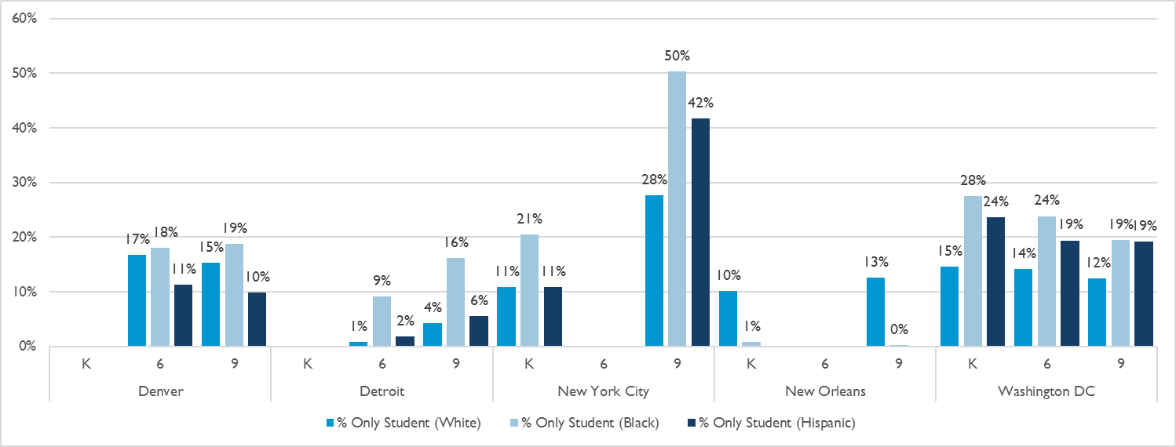

Black students are more likely than white students to be the only student from their neighborhood to attend their school. This difference is particularly distinct at the high school level, where black students are anywhere from 4 percentage points (Denver) to 23 percentage points (New York City) more likely to be the sole representative of their neighborhood relative to white students. In three of our cities, Hispanic students are as likely or more likely to be the only ones from their neighborhood at their school relative to white students, while in Denver, they are less likely to be the only ones from their neighborhood.

***Who Travels to Quality Schools?***

*Consult with team if they want to do analysis*

***How Do Transit Policies Align With Our Results?***

Regressions with dominant transportation mode?

**Limitations**

Only limited to entry grades, so students could leave/transfer to closer schools

One year of data

Don’t observe transportation mode itself

**Conclusions**

Sources

Geography in Parental Choice

Courtney Bell

Educational Testing Service

**Appendix I: City-Level Methodologies**

**Denver**

**Detroit**

a. Sample: School Year 2013-14 Source: Michigan Department of Education (MDE) and the Center for Educational Performance and Information (CEPI)

b. Data decisions:

1. Restricted sample to students who live within the boundary of Detroit Public Schools (DPS) AND attended a traditional public school or a charter school within the district boundaries of DPS

2. If student appeared multiple times in the data set in one year due to multiple home addresses or schools attended, we use first observation in the data set. We did not have information on which school the student attended first.

c. City-specific distance decisions: For distances within a 2 mile radius, drive time was calculated from student census block to school census block. For distances further than 2 miles, distance was calculated from student census tract to school census tract.

DISCLAIMER: This research result used data collected and maintained by the Michigan Department of Education (MDE) and/or Michigan’s Center for Educational Performance and Information (CEPI). Results, information and opinions solely represent the analysis, information and opinions of the author(s) and are not endorsed by, or reflect the views or positions of, grantors, MDE and CEPI or any employee thereof.

**New Orleans**

Data for student-level New Orleans analyses come from the Recovery School District (RSD) and Louisiana Department of Education (LDOE). We report data for kindergarteners and 9th grader—the transition grades for most New Orleans schools—who applied for schools through the city’s unified enrollment system, the OneApp, for the 2013-14 school year. Students are assumed to have enrolled at the school they were assigned to in the final round of OneApp assignment.

State administrators report that 79% of New Orleans public schools were available in the OneApp for the 2013-14 year (EnrollNOLA, 2016). All OneApp schools in 2013-14 offered open enrolment to students across the city, with no selective admissions. Notably, several of the city’s highest-performing, highest-demand public schools (both with and without admissions requirements) were not available in the OneApp at that time. Private schools that participated in the state voucher program, the Louisiana Scholarship Program (LSP), also appeared in the OneApp. The students who applied for private schools through the OneApp are included in these analyses (e.g., in identifying where students live in the city). The private schools are not included in these analyses (e.g., in identifying where schools operate in the city). The OneApp was the primary access point for public schools, so the OneApp data used for this report contain observations for the vast majority of students who enrolled in public schools. Students who enrolled in an LSP-participating private school without receiving a voucher themselves might not have participated in the OneApp and therefore might not appear in these data.

Our OneApp data do not include information about students’ race, ethnicity, or family income. For the subgroup analyses in this report, the New Orleans data are disaggregated based on the characteristics of the Census block groups in which students live. Census block group information comes from the five-year estimates of the 2015 American Community Survey (ACS). For race/ethnicity, we disaggregate by whether the plurality of a Census block’s population is Black (non-Hispanic/Latino), White (non-Hispanic/Latino), Asian (non-Hispanic/Latino), or Hispanic/Latino. For family income, we calculated the percentage of each Census block group’s population that had received benefits from the Food Stamp Program or the Supplemental Nutrition Assistance Program (SNAP) in the past 12 months. We then divided all Louisiana Census block groups into quartiles. We disaggregate results by these quartiles based on where students lived. For some students, characteristics of their block group (e.g., the plurality race/ethnicity) likely does not match the student’s own characteristics (e.g., the student race/ethnicity).

In the analyses that disaggregate by charter and traditional school, we classify Orleans Parish School Board (OPSB) direct-run schools (n=6) and RSD direct-run schools (n=2) as traditional. OPSB direct-run schools were managed by the local school board. RSD schools were managed, temporarily, by the RSD (a state agency). Both OPSB and RSD direct-run schools were schools of choice—i.e., they did not have neighborhood attendance zones or selective admission—but generally had less school-level autonomy than the city’s charter schools.

**New York City**

This analysis draws on several administrative data sources from the NYCDOE: (1) residential addresses, demographic, and programmatic information for all students enrolled in NYC public schools; and (2) addresses, descriptive characteristics, and performance measures for all NYC public schools. We focus here on students enrolled in kindergarten and 9th grade---and the schools that offered these grade levels---in 2013-14.

Residential addresses were geocoded using Geosupport Desktop Edition software from the NYC Department of City Planning. This software is the official geocoder of the city government, and is generally better at parsing unusual NYC addresses than other available packages. These counts include charter school students but exclude students enrolled in alternative schools or schools that exclusively serve students with disabilities (District 79 and 75 schools, respectively). We used ArcGIS and Census block boundary files to assign geocoded student addresses to 2010 Census block IDsThe addresses for the 162,625 unique students across both grades were located in 23,804 unique Census blocks (19,845 for KG and 19,863 for 9th grade, not mutually exclusive).

Enrollment data from the NYCDOE Demographic Snapshot was used to identify schools offering either kindergarten or 9th grade. These counts again exclude alternative and special education schools. School addresses from March 2014 were obtained from the NYCDOE Location Code Generation Management System (LCGMS). Using an online geocoding tool, we obtained spatial coordinates (latitude and longitude) and 2010 Census block IDs for the 1,406 unique schools serving kindergarten or 9th grade. These schools were located in 1,056 unique Census blocks (821 for KG and 306 for 9th grade, not mutually exclusive).

Calculating travel time between all unique home and school block combinations would be computationally intensive and expensive. (There are roughly 25 million unique block pairs for the two grades combined). To reduce the scope of this analysis, we first eliminated kindergarten block pairs in different boroughs. This decision was justified given that most kindergarten students (97.8%) in NYC attend their residentially-zoned school in the same borough. Eliminating pairs in different boroughs significantly reduced the total number of block pairs from 25.1 to 9.7 million. We did not make this restriction for 9th graders, since many do attend a school outside of their borough of residence.

To reduce the number of combinations further, we calculated the straight-line distance between centroids of each student and school block. If the straight-line distance was more than 5 miles (for kindergarten pairs) or more than 10 miles (for 9th grade pairs), the block pair was eliminated, under the assumption that students in these grades would not travel that far to school (the 95th percentile of straight-line distance between home and current school for 9th graders was 9 miles. For kindergarten, it was 2.2 miles. Thus, trips this far are very rare in the data.) This further reduced the total number of block pairs from 9.7 to 5.7 million.

For the remaining block pairs, we calculated travel time between student and school using block centroids when the straight-line distance was less than 1 mile. When the straight-line distance was 1 mile or more, we calculated travel time between student and school blocks using tract centroids. Because tracts encompass a larger land area than blocks, this markedly reduced the number of required calculations. For a random sample of 500 block pairs, we compared the travel time calculated using block and tract centroids. For driving time, the correlation was 0.987. For public transit time, the correlation was 0.981.

**Washington DC**

Data for student-level Washington DC analyses come from the District of Columbia Public Schools (DCPS) and from the District of Columbia Public Charter School Board (PCSB). We report data for all kindergarteners, 6th graders, and 9th graders who were enrolled in either traditional or charter schools in DC in the 2013-2014 school year.

In cases where students are enrolled in more than one school over the course of the school year, we record the first enrollment, by entry date, as the enrollment for which we calculate travel distance and times. We exclude students who are recorded as attending schools outside the district or who report non-DC addresses. A very small number of students (less than ten) were recorded as enrolled in a school that does not offer the grade that they are enrolled in, and were also excluded from the analysis.

A student’s low-income status is recorded as receiving free- or reduced-price lunch in the 2013-2014 enrollment year. A student is recorded as a charter school student if their first recorded enrollment is a charter school.

**APPENDIX 2**

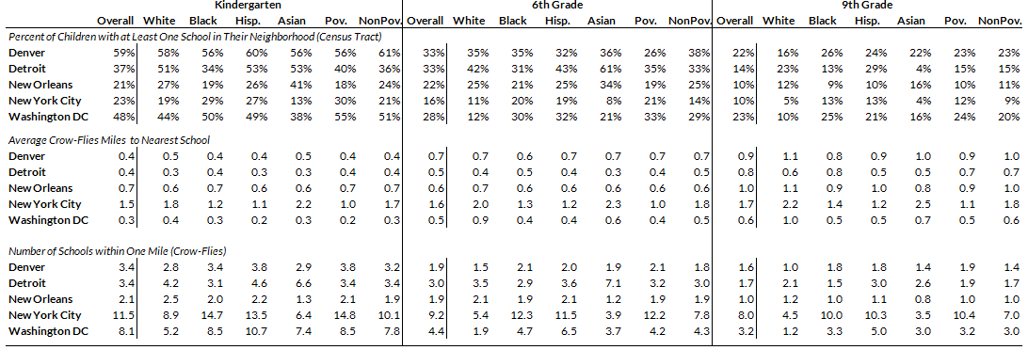

1. In Detroit and New York City, distant schools were measured using tract-to-tract centroids, to reduce the number of calculations required. See appendix for more details on each city.